Haskell Set 5
1. What is the type of the expression 1+1? Explain this as if you are trying to
explain it to an AP student.
The type of the expression 1+1 is type Num because the + function does not exclude any type of number
2. What is the type of max? Explain each part of it as if you are trying to explain
it to an AP student.
The type of the expression max is of type Ord because all of the parameters must be able to use comparison operators
3. If you were to write a function to calculate the average of two integers, how would
you define the type of the function?
avg :: Fractional a => a -> a -> a
4. If you were to write a function to find the mode of a list of anything that uses
the = sign, how would you define the type of the function?
mode :: Eq [a] => [a] -> Int
5. Explain the difference between Int, Integer, Integral in words that an AP student
could understand.
The Int type encompass whole numbers that are of relatively small size, while the Integer type is the same, but they are much larger in capacity, and Integrals yet encompass both.
6. You want to write a function that finds the second largest piece of information in
a list - but you don't know how to write the Type of the function. Explain how you
could figure out the Type of the function by using other things.
You can write the function in how it is supposed to compute, and then then use
:t funtionName
7. Write a function that calculates the area of a trapezoid. Allow very precise
decimals to be sent in.
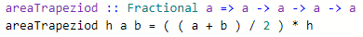
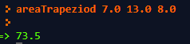
8. Write your own version of the tail function on a list, make sure to define the
type.
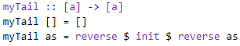

9. Write a pythagorean theorem function which returns true if a^2 + b^2 equals c^2.
Limit a, b, and c to integers.
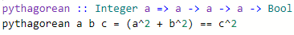
10. Write an inAscendingOrder function which will work on any list as long as the list
items themselves are comparable with the > or < sign, and returns true if they are
in ascending order. 
11. Write a function that takes in two numbers that are currently stored in strings,
then returns the values subtracted. Ex: subt "342" "330" -> 12

12. Write a function that finds the average (as a decimal), with minimal precision, of
a list of numbers.
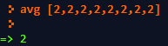
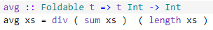
13. Write a function that given a list of Strings, where each String is really a
number like "3.2" or "5", converts them to a list of numbers.
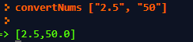
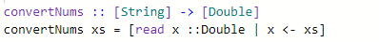
14. Explain how an AP student is like a toddler.
To answer the enigmatic question of how an AP student is like a toddler, we must first understand and comprehend the nature of the human condition. One of the greatest Greek philosophers, Plato, once put forth his famous Allegory of the Cave, wherein he posits the idea that humans only attempt comprehend the scope of the situation that they understand, and experience great revelation when shown ideas outside of that, be they mere ideas or actual places. Arguably the most perplexingly insightful thing about that Allegory, albeit most likely unintentional, is that the story structure of the allegory continuously reveals itself in modern forms of media, and, in many cases, real life. Study of this trend has led to the conclusion that the human condition never seems to evolve, and we seem to carry with us some sorts of malleable tendencies and desires that stay with us throughout time and history. They persist despite our superior ability to teach and translate information through generations, despite our ability to be constantly improving upon our past mistakes, we still are the same.
This brings us back to the relationship between AP Students and toddlers. Toddlers have always existed throughout the history of humanity, but AP Students may be what you consider the ‘new kids on the block’. Both groups are still humans, however, and as such, they still fall prey to the human condition. Both AP Students and toddlers fail to recognize the scope outside what is important to them at that point in time, be it a difficult class, or a game of Peek-a-Boo. Both such cannot help but form feelings of anger or sadness upon not receiving a good grade, or maybe a sweet piece of candy (in both cases, if I may be so bold).
In conclusion, the maturity of toddlers and AP Students are comparable in the sense that they are arguably equivalent. Of course, it is most important to realize that both toddlers and AP students are more than capable of growing, changing, maturing, and passing down the knowledge that they have earned from the trial that is life down to the future barons of the Earth.

